**Creating a DynamoDB Table with a Partition Key**

### Introduction

In this lab step, you will create a Dynamo DB table. Creating a DynamoDB table is simple and can be done using the AWS Management Console.

### Instructions

1. From the AWS Management Console, in the search bar at the top, enter DynamoDB, and under **Services**, click the **DynamoDB** result:

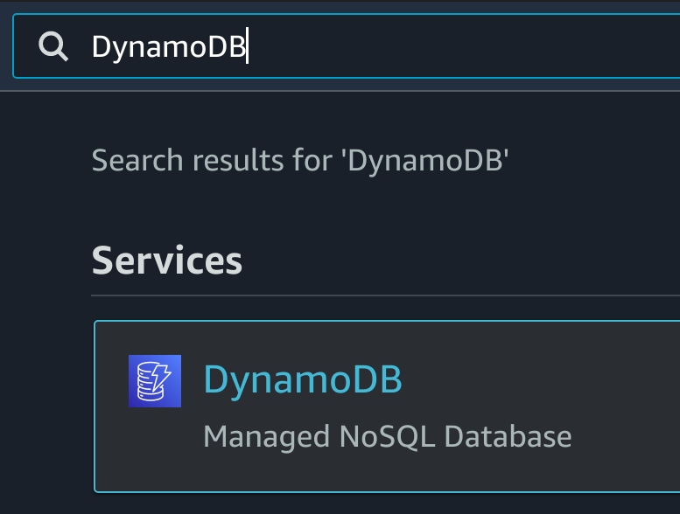

The Amazon DynamoDB product overview page will load.

2. To start creating a new DyanmoDB table, on the right-hand side, click **Create table**:



3. In the **Table details** section, enter the following:

* **Table Name**: Forum
* **Partition Key**: Enter Name and ensure type is **String**

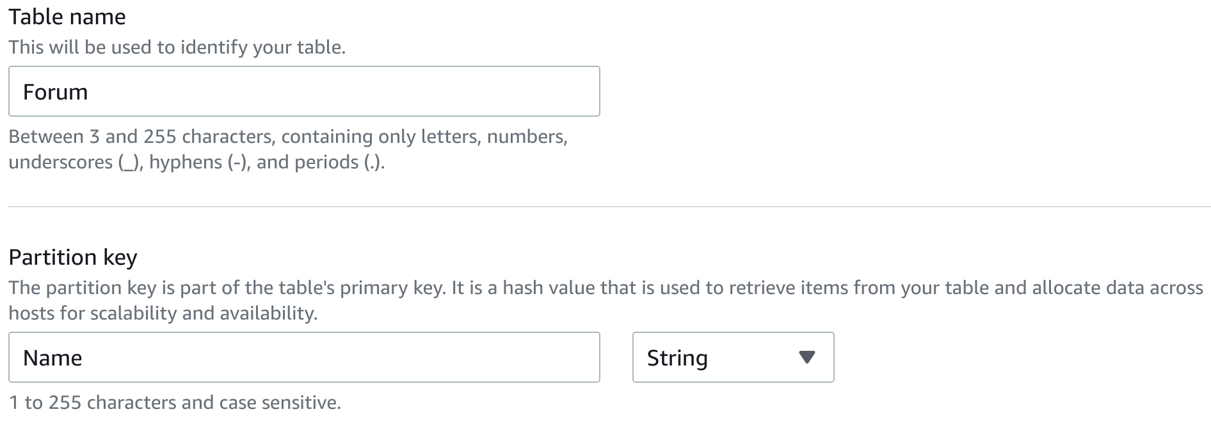

4. In the **Settings** section, select **Customize settings**:

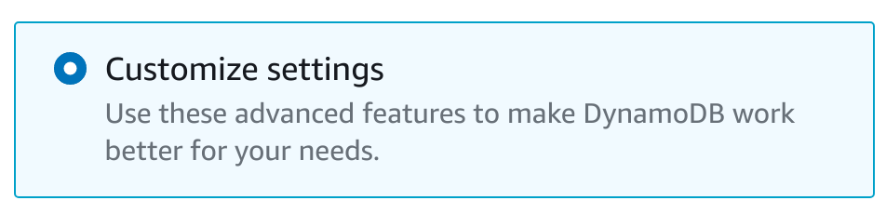

Choosing this option allows you to specify values for the table's read and write capacities.

5. In the **Read/write capacity settings** section, under **Capacity mode**, select **Provisioned** and enter the following:

* **Read Capacity**:
  + **Provisioned capacity units**: 10
* **Write Capacity**:
  + **Provisioned capacity units**: 2

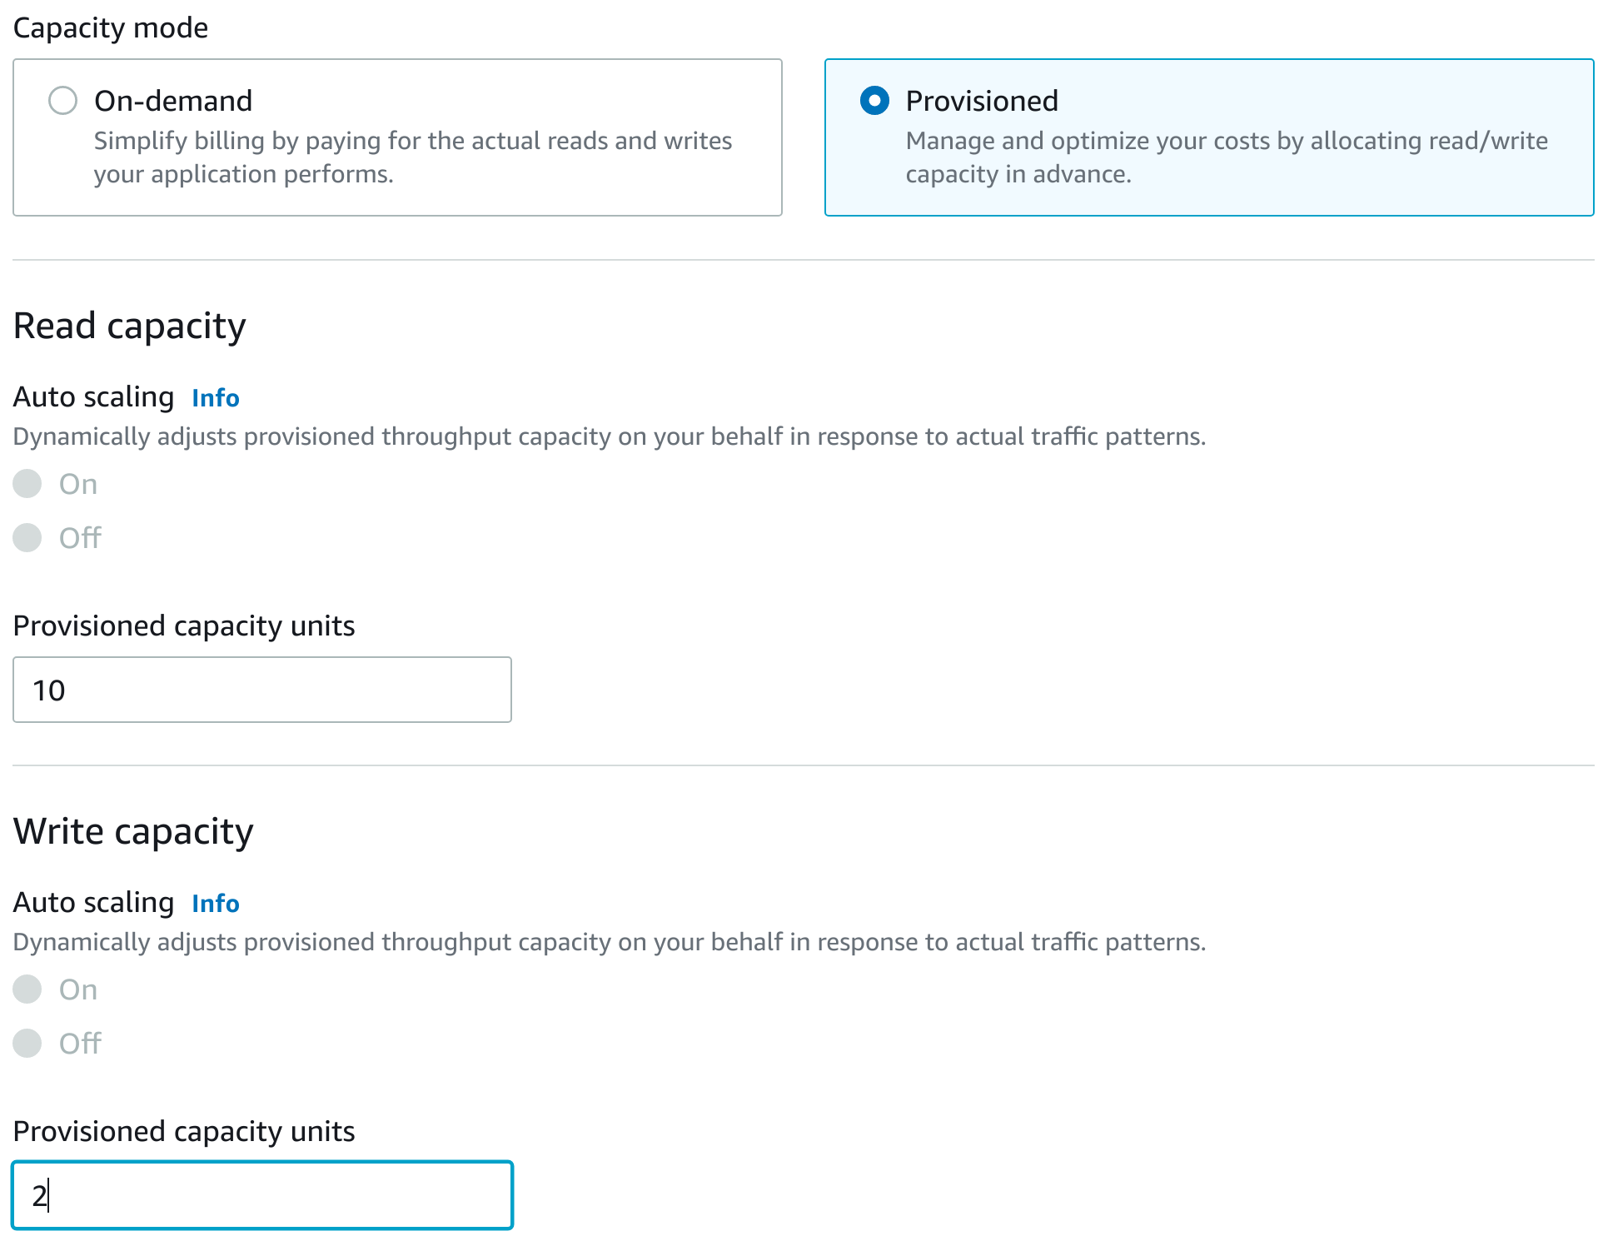

Accept the defaults for all other options on this page.

6. Scroll to the bottom and click **Create table**:



The **Tables** list view will load and you will see a notification that your table is being created. After a 30 seconds or so, you will see a success notification:



### Summary

In this lab step, you created a DynamoDB table.

VALIDATION CHECKS

**1Checks**

Start check

**Forum DynamoDB Table Exists**

A DynamoDB table called Forum exists

Amazon DynamoDB

# Creating a DynamoDB Table with Local and Global Secondary Indexes

### Introduction

In the previous lab step, you created a DynamoDB table with a partition key. In this lab step, you will create a new two new tables. one with a local secondary index and another table with two global secondary indexes.

### Instructions

1. On the right-hand side of the page, click **Create table**:



2. Enter the following in the **Table details** section:

* **Table name**: Thread
* **Partition key**:
  + **Name**: Enter ForumName
  + **Type**: Select **String**
* **Sort key**:
  + **Name**: Enter Subject
  + **Type**: Select String

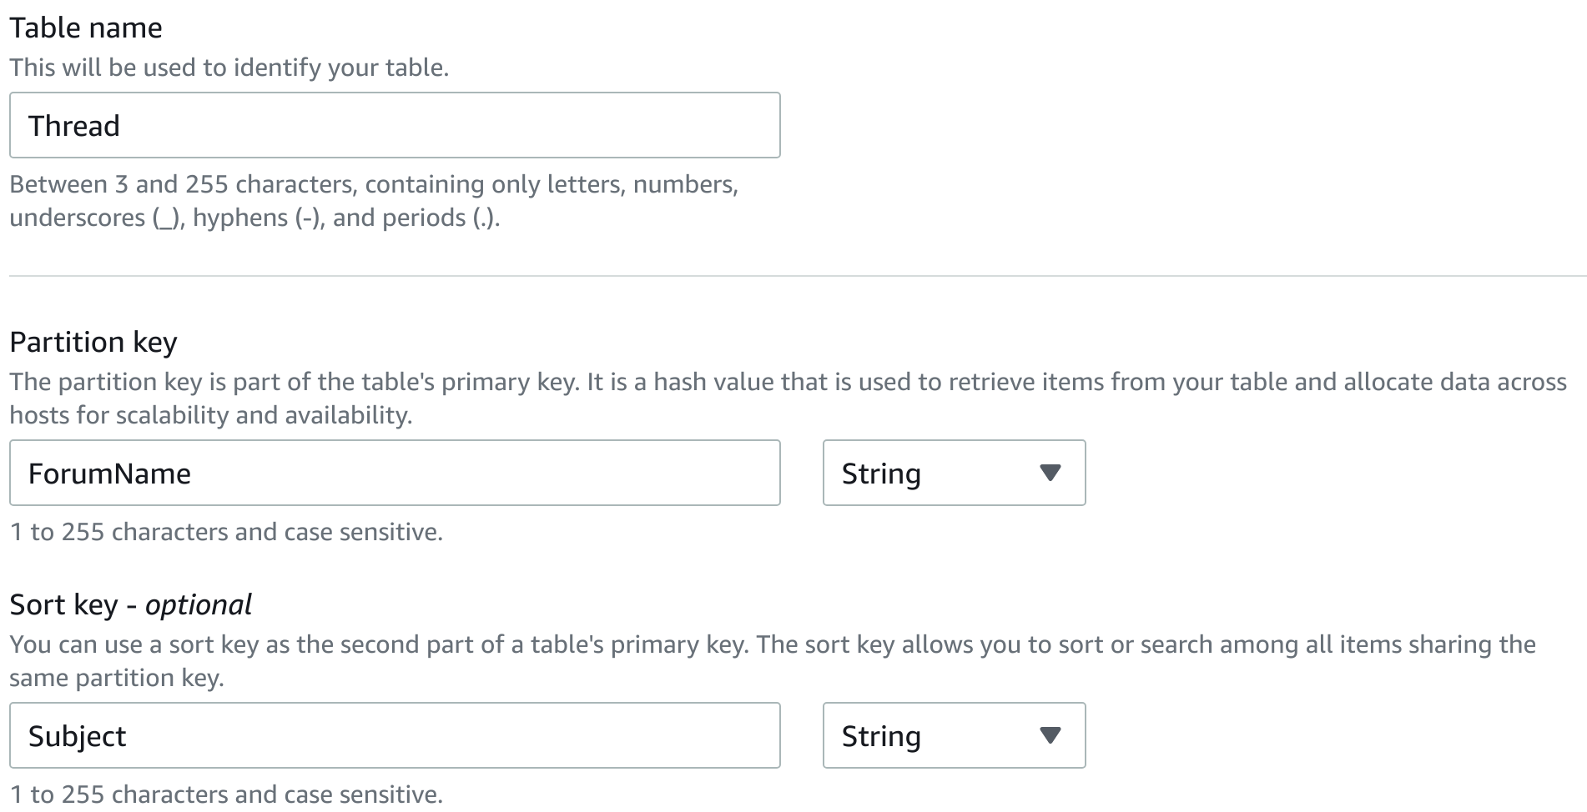

3. In the **Settings** section, select **Customize settings**.

4. Under **Read/write capacity settings**, ensure **Provisioned** is selected for **Capacity mode**, and enter the following:

* **Read capacity**:
  + **Provisioned capacity units**: 10
* **Write capacity**:
  + **Provisioned capacity units**: 2

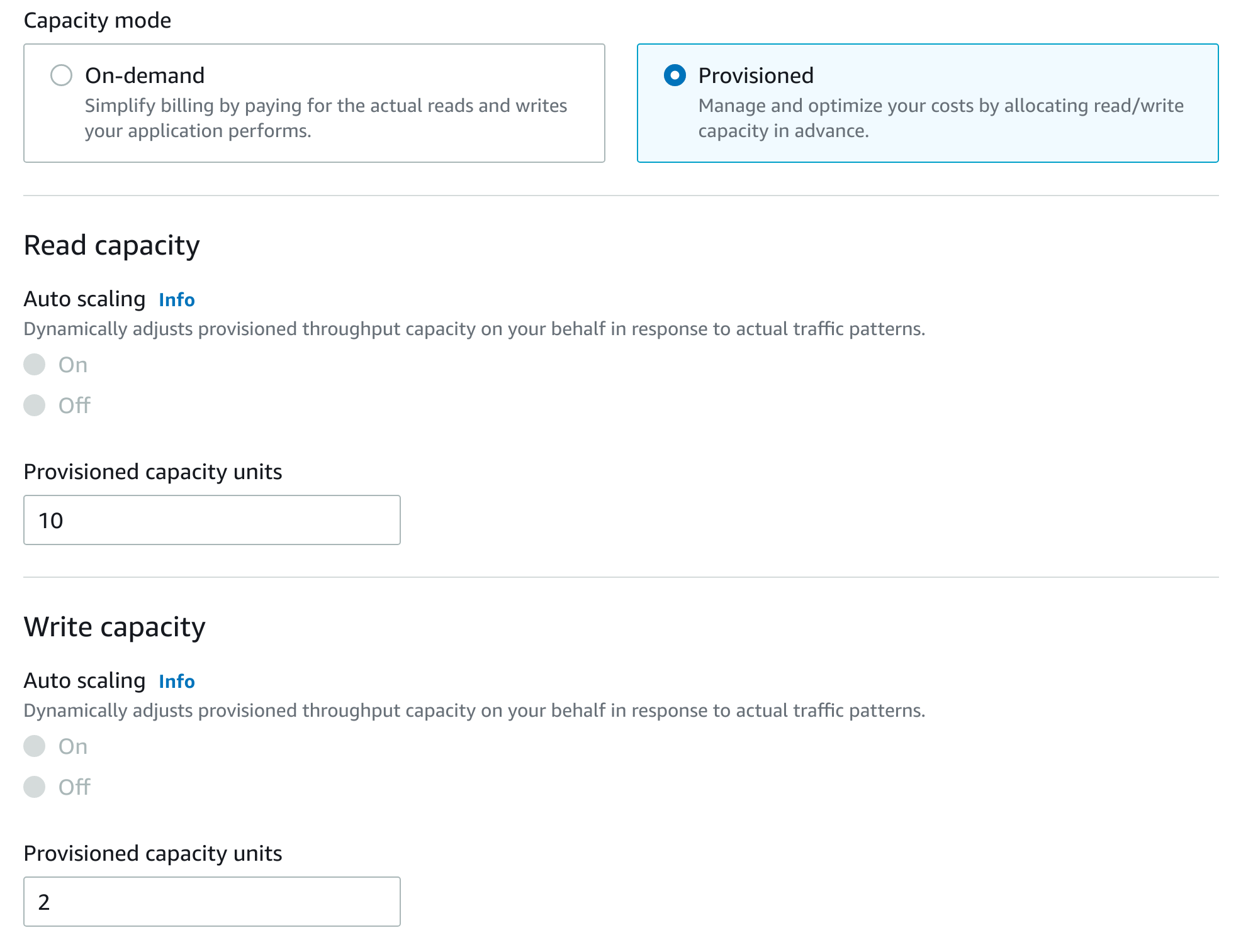

5. Scroll down to the **Secondary indexes** section and click **Create local index**:

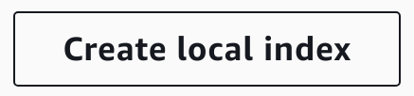

The **New local secondary index** dialog box will appear.

6. Enter the following to configure your local secondary index:

* **Sort Key**:
  + **Name**: Enter CreationDate
  + **Type**: Select **String**
* **Attribute projections**: Select **All**

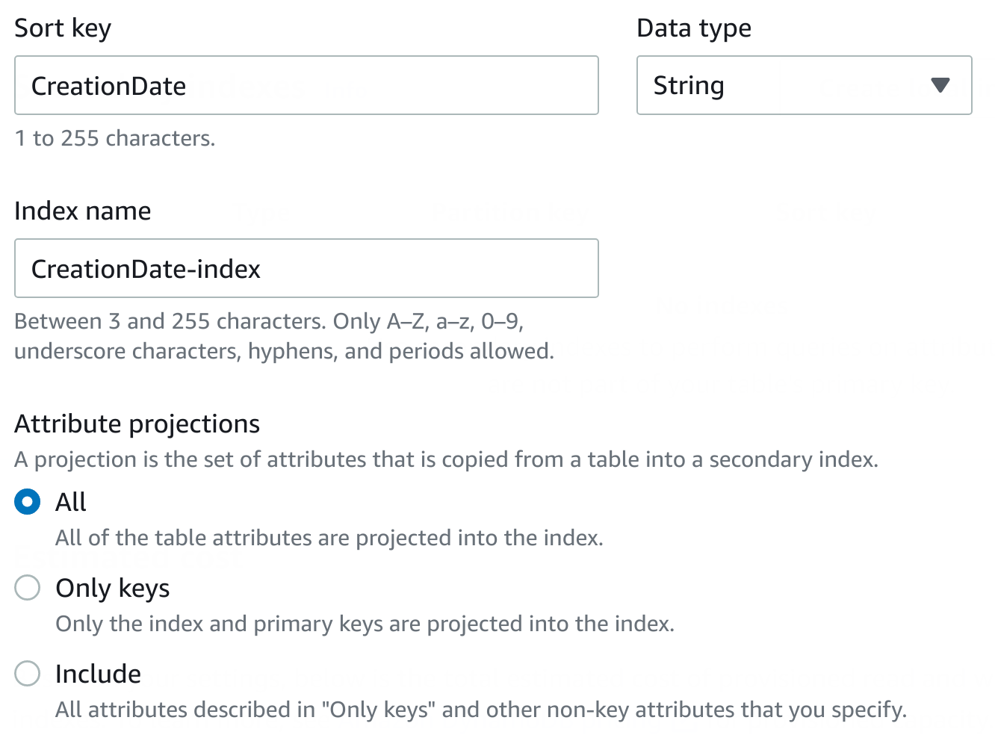

An LSI (Local Secondary Index) has the same partition key as the table's primary key and will share the provisioned capacity of the table in contrast to global secondary indexes which provision their own capacity.

7. To finish creating the local secondary index, at the bottom, click **Create index**:

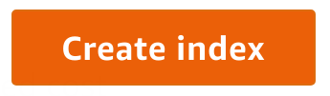

8. Scroll to the bottom and click **Create table**.

After roughly 30 seconds you will the table become active:

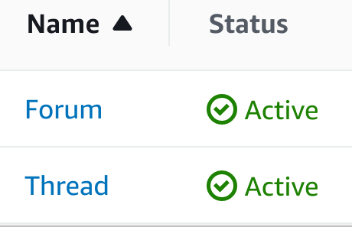

In contrast to a Local Secondary Index, a Global Secondary Index is an index with a partition and sort key that can be different from those in the table. It is considered "global" because queries on the index can span all of the data in a table, across all partitions.

9. Click **Create table** once more to start creating another table.

10. Enter the following in the **Table details** section:

* **Table Name**: Reply
* **Partition key**:
  + **Name**: Enter ID
  + **Type**: Select **String**
* **Sort key**:
  + **Name**: Enter CreationDate
  + **Type**: Select **String**

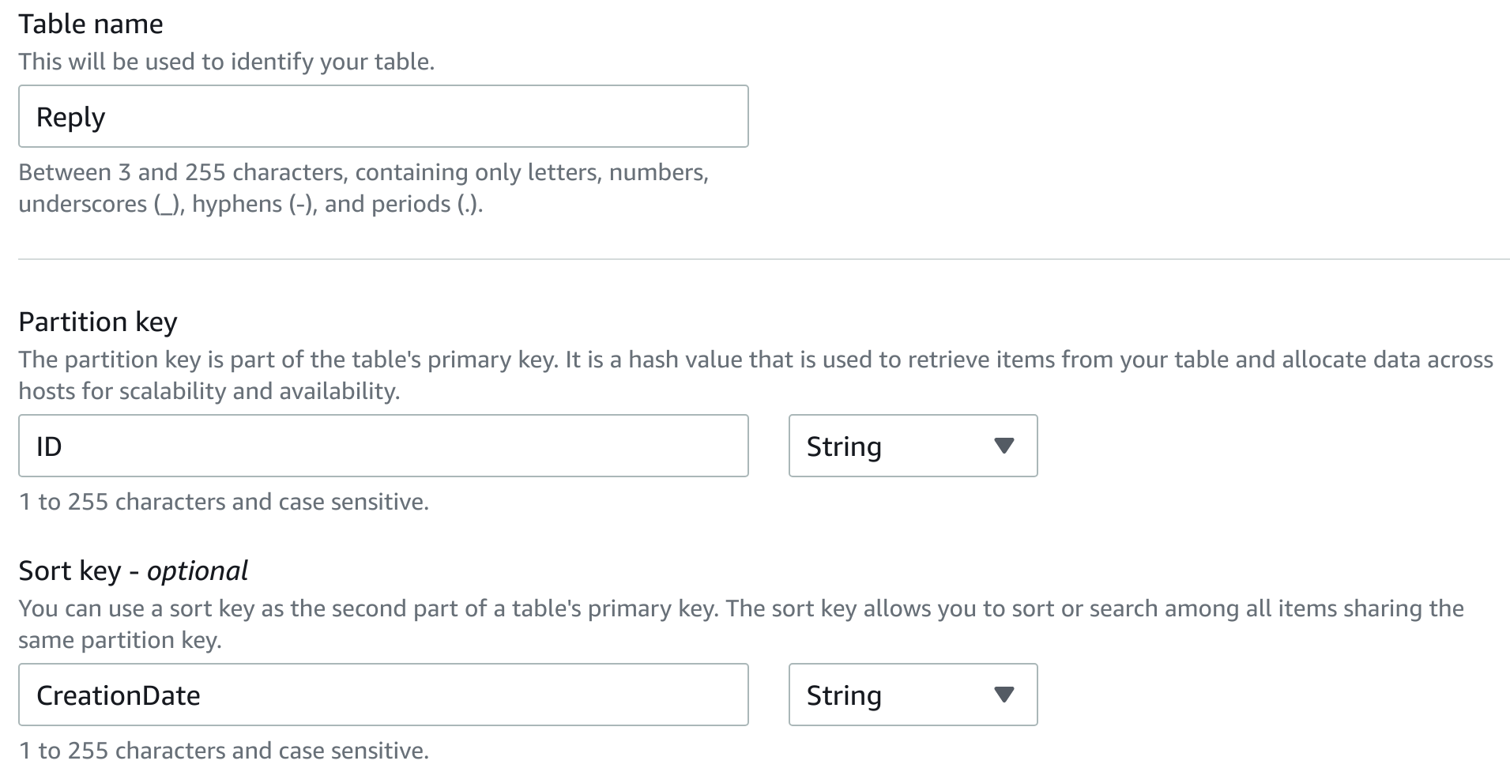

11. In the **Settings** section, select **Customize settings**.

12. In the **Read/write capacity settings** section, ensure the **Capacity mode** is **Provisioned**, and enter the following:

* **Read capacity**:
  + **Provisioned capacity units**: Enter 10
* **Write capacity**:
  + **Provisioned capacity units**: Enter 5

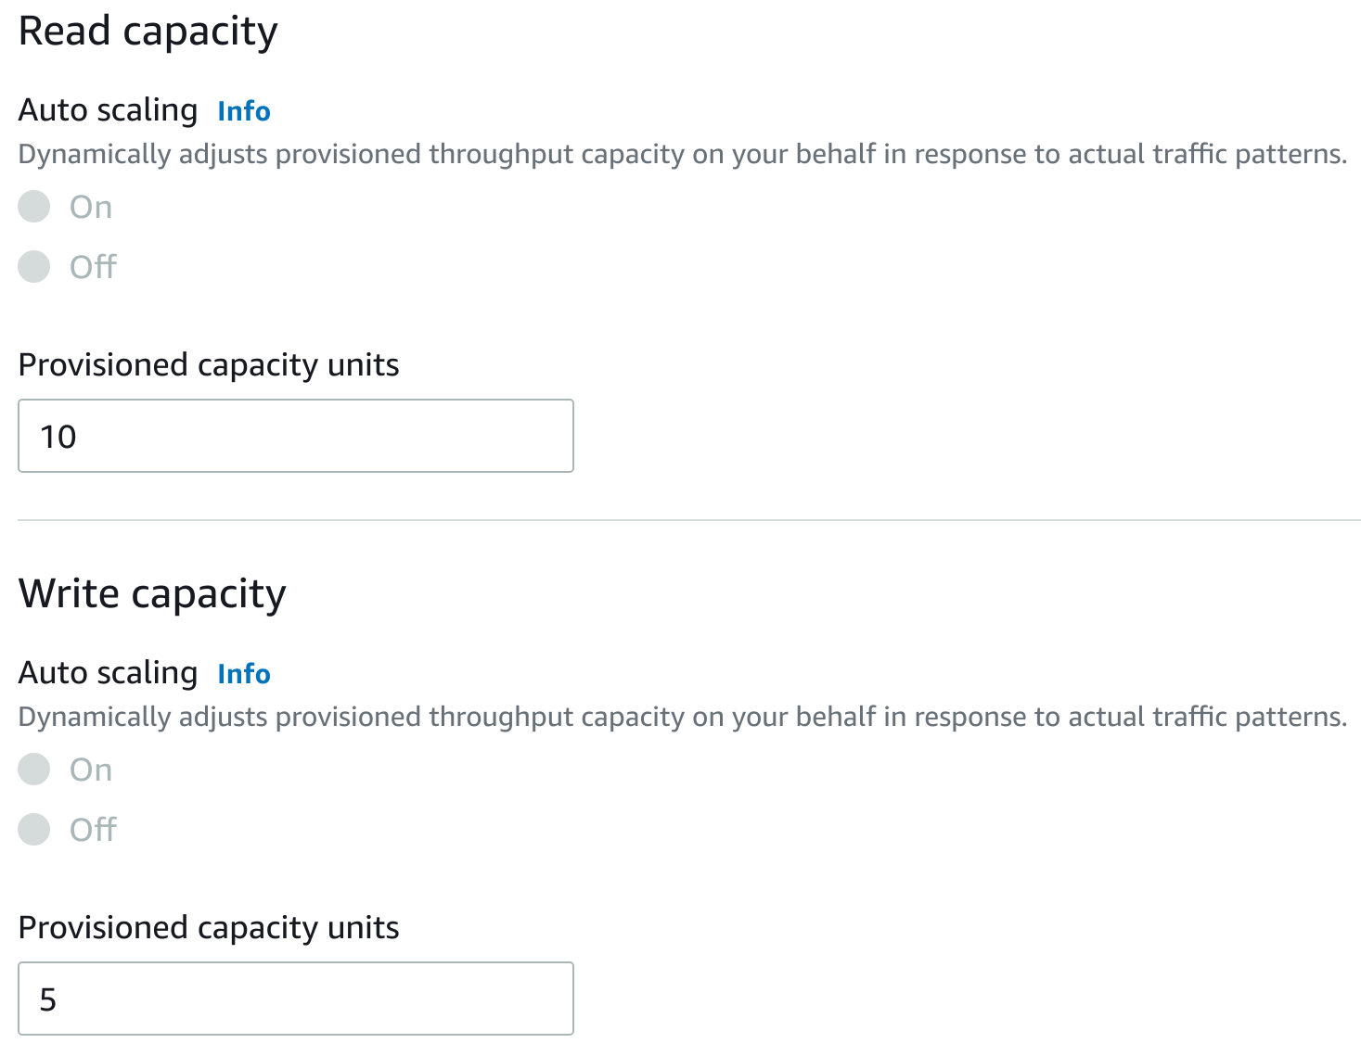

13. Scroll down to the **Secondary indexes** section, and click **Create global index**:

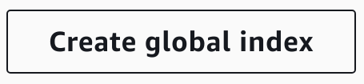

The **New global secondary index** dialog form will appear.

14. Enter the following:

* **Partition key**:
  + **Name**: Enter ID
  + **Type**: Select **String**
* **Sort key**:
  + **Name**: Enter Sticky
  + **Type**: Select **String**
* **Attribute projections**: Select **All**

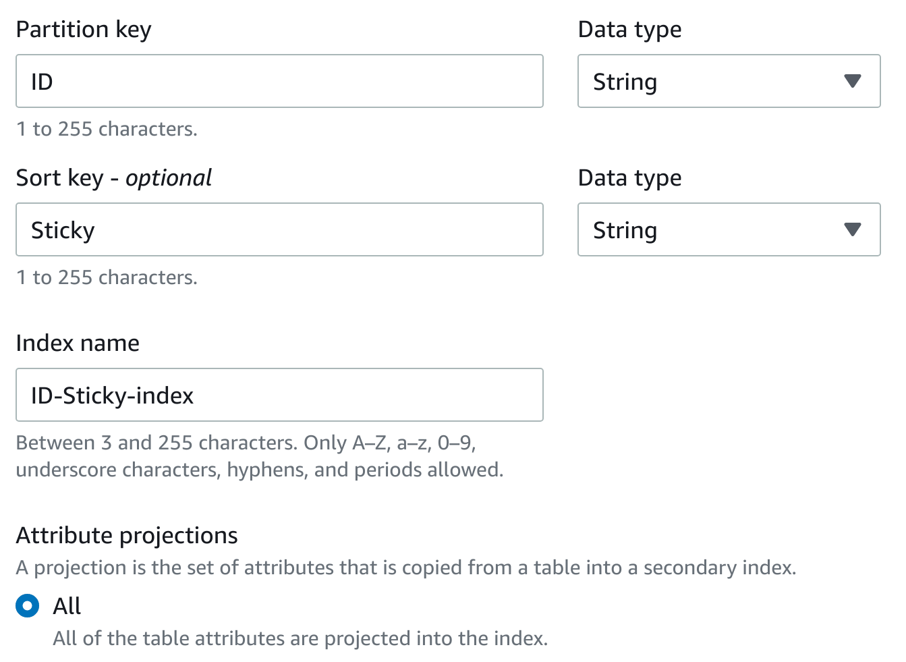

15. To finish creating the global secondary index, at the bottom, click **Create index**.

16. Click **Create global index** again and enter the following:

* **Partition key**:
  + **Name**: Enter AuthorId
  + **Type**: Select **String**
* **Sort key**:
  + **Name**: Enter CreationDate
  + **Type**: Select **String**
* **Attribute projections**: Select **All**

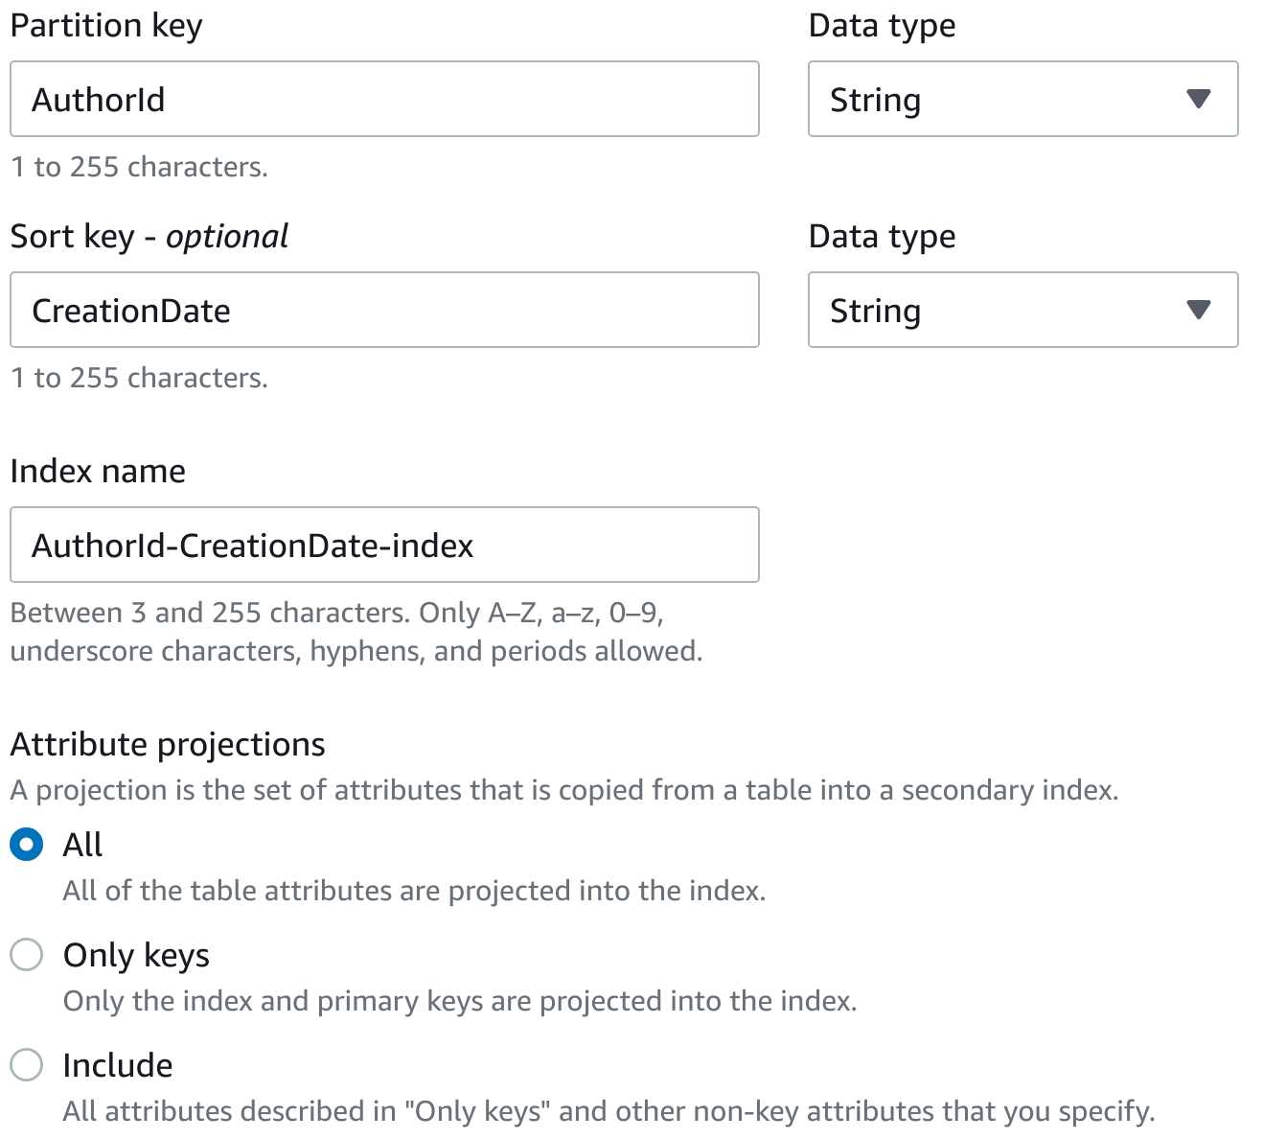

17. To finish creating the global secondary index, at the bottom, click **Create index**.

18. Scroll to the bottom and click **Create table**.

Once again, you will see your table created after roughly 30 seconds.

### Summary

In this lab step, you used the **DynamoDB** dashboard to create multiple DynamoDB tables with local and global secondary indexes.

# Inserting Items Into a DynamoDB Table

### Introduction

After creating all the needed tables, you are ready to fill them with demo data.

### Instructions

1. In the left-hand menu, click **Explore items**:

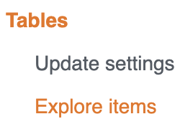

2. In the **Tables** list, select **Forum**

You will see nothing under **Items returned** because there are no items stored.

3. On the right-hand side, click **Create item**:

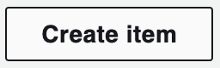

The **Create item** form will load and you will see a list of **Attributes**.

4. In the **Value** textbox next to **Name - Partition key**, enter a name for your forum (can be anything you wish):

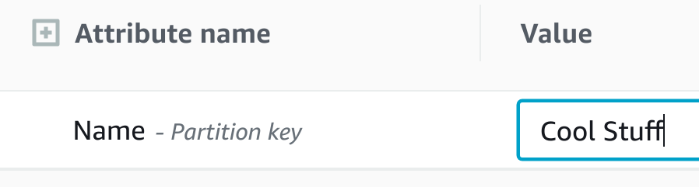

5. To add another attribute for this item, click **Add new attribute** and select **String** from the list of types:

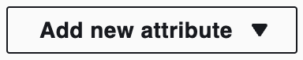

6. In the **Attribute name** textbox, enter Description and in the **Value** textbox, enter any value you'd like:

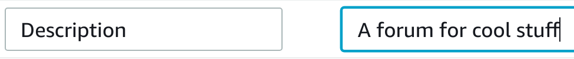

7. At the bottom, click **Create item**:

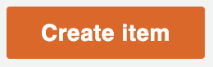

8. Repeat steps 3-7 three more times so that end up with four entries in the **Forum** table:

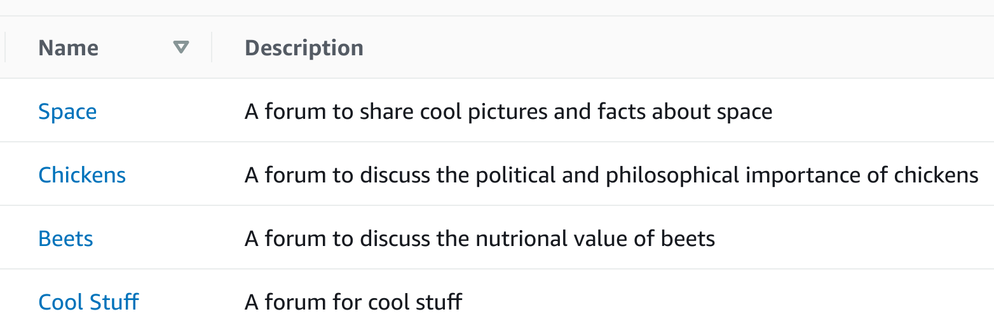

9. Select the **Thread** table and click **Create Item**.

10. Provide any values you'd like for **ForumName**, **Subject** and **CreationDate**, keeping in mind that the **ForumName** value must match the name of one of your forums.

Note: Thread is a "Partition and Sort" table with the CreationDate-index Local Secondary Index. For being able to save a Thread item, you have to provide:

* ForumName (the table Primary Key)
* Subject (the table Sort Key)
* CreationDate (the Local Secondary Index Sort Key)

Note: You will have to click **Add new attribute** to add the **CreationDate** attribute and specify a value.

11. At the bottom, click **Create item**.

12. Repeat steps 9-11 three more times until you have four items in the **Thread** table:

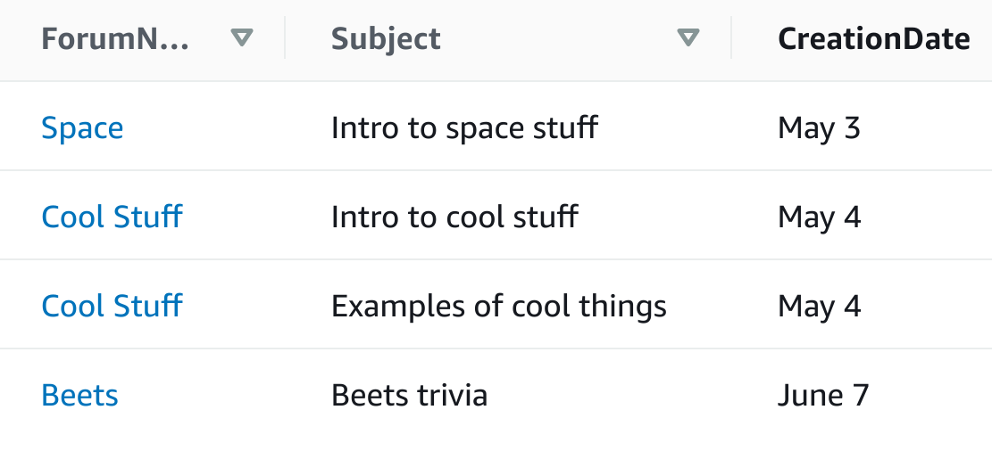

### Summary

In this lab step, you inserted several items into two of your DynamoDB tables.

VALIDATION CHECKS

**1Checks**

Start check

**Thread DynamoDB Table Exists and Has an Item**

A Dynamodb table called Thread exists and has at least one item

Amazon DynamoDB

# Editing DynamoDB Table Items

### Introduction

The AWS Management Console also allows you to edit previously created items.

### Instructions

1. On the **Explore items** page, select the Forum table:

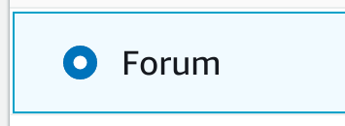

2. Select any item in the table and click on its name to get to the **Item editor** page:

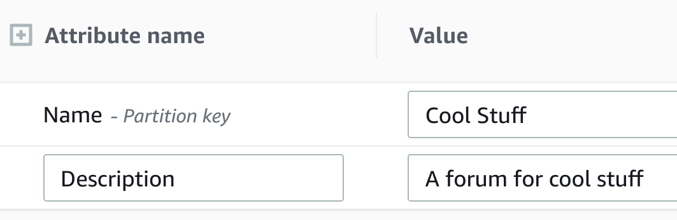

3. Click inside any value and make an update to its contents:



Warning: Note that modifying the partition key will result in changing the values of the item keys. This will delete and recreate the item with new keys.

4. At the bottom of the page, click **Save changes**:

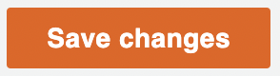

### Summary

In this lab step, you used the **DynamoDB** console to edit items in a table.

# Querying a DynamoDB Table

### Introduction

DynamoDB provides two commands for searching data on the table: scan and query. A scan operation examines every item on the table and returns all the data attributes for each one of them. When you initially navigate to the **Items** tab for a table, a scan is performed by default.

In this lab step, you will practice querying a table.

### 

### Instructions

1. In the left-hand menu, click **PartiQL editor**:

alt

The **PartiQL editor** page will load.

PartiQL is a SQL (Structured Query Language) compatible language for Amazon DynamoDB. As well as querying tables, you can use it to insert new items and update existing ones.

2. Under **Tables**, click the three dots next to the  **Thread** and click **Scan table**:

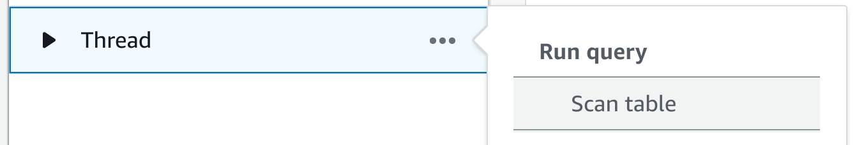

The **Query 1** editor will be populated with a PartiQL query that selects all items from the  **Thread**.

3. To execute the PartiQL table, under the editor, click **Run**:

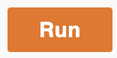

4. Scroll down to see the results under **Items returned**:

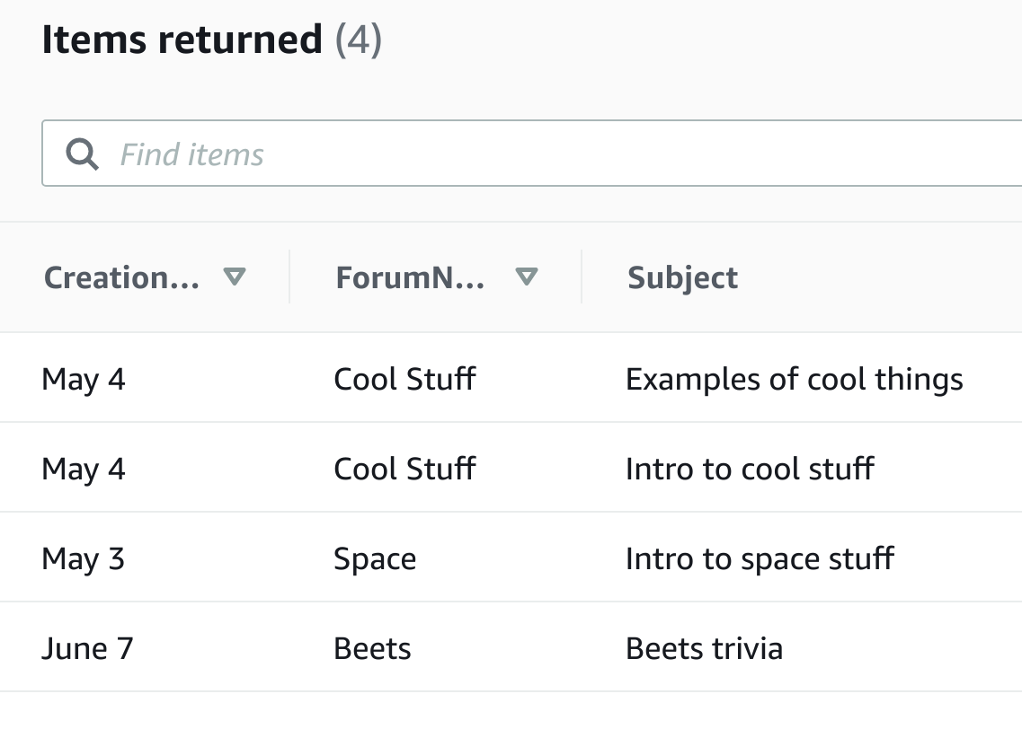

Notice that you have a choice of viewing the results in tabular form or in JSON (Java Script Object Notation):

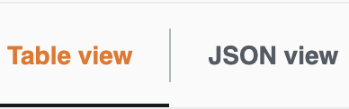

5. To query for a specific item, replace the contents of the **Query 1** editor with the following, and click **Run**:

[**Copy code**](https://cloudacademy.com/lab/introduction-dynamodb/query-a-dynamodb-table/)

1

**SELECT** * **FROM** "Thread" **WHERE** "Subject" = 'Intro to cool stuff'

This time, you will only see items returned that satisfy the value of the WHERE condition.

Note: Change the value of the WHERE condition to match an item you created if you don't see a result.

PartiQL supports most standard features of SQL which means you can query, select, and sort your data in sophisticated ways.

Typically, using the Amazon DynamoDB Console to query items is useful for one-off reports and debugging or troubleshooting. Like most databases, DynamoDB can be accessed programmatically by other systems and software applications through either the AWS SDK (software development kit) or DyanmoDB's HTTP API (application programming interface).

You can learn more about using PartiQL with Amazon DynamoDB by visiting the [Working with PartiQL Query Language](https://docs.aws.amazon.com/amazondynamodb/latest/developerguide/ql-reference.html) section of the Amazon DynamoDB developer guide.

### Summary

In this lab step, you practiced using the **DynamoDB** dashboard to query a table.

# Deleting a DynamoDB Table

### Introduction

You can delete a DynamoDB table using the **DynamoDB** dashboard in the AWS Management Console. In this lab step, you will practice deleting a table.

### Instructions

1. In the left-hand menu, click **Tables**:



2. In the **Tables** table, select the **Thread** table:

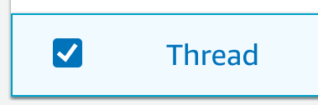

3. On the right-hand side, click **Delete**:

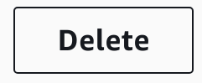

The **Delete table** confirmation modal will appear.

Notice that you have the ability to create a backup for a table before deleting it.

4. In the confirmation textbox, enter delete and click **Delete table**:

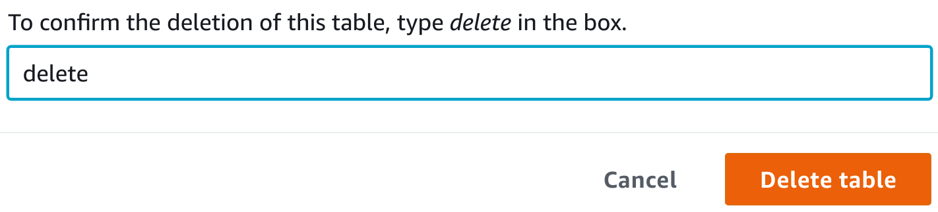

You will see a message summarizing the deletion:

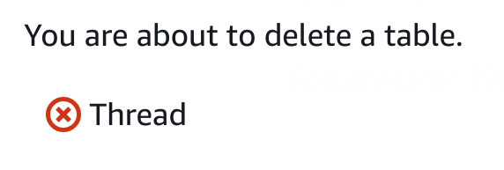

5. To continue, click **Go to tables**:

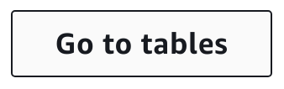

6. To update the **Tables** table, click the refresh icon:

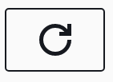

You will now see only two tables listed.

### Summary

In this lab step, you used the **DynamoDB** dashboard to delete a DynamoDB table.

VALIDATION CHECKS

**1Checks**

Check again

**Deleted the DybamoDB Table**

Check that the **Thread** DynamoDB table has been removed.

Amazon DynamoDB

Submit

